9th International Conference on Asian Marine Geology (ICAMG-9)
Oct. 10-12, 2018, Shanghai
First Circular
Theme: Progress and perspectives of marine geology in Asia
https://icamg-9.tongji.edu.cn
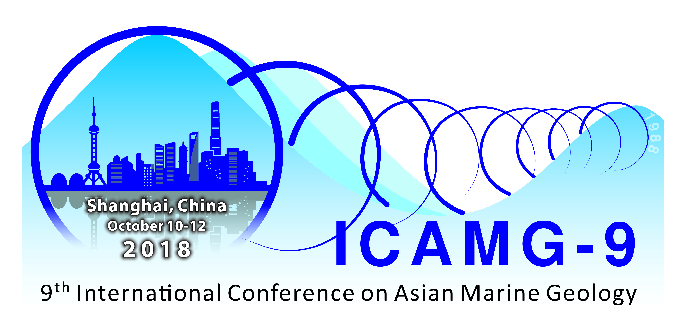
In September 1988, the First International Conference on Asian Marine Geology was held in Shanghai. Since then Asia has witnessed its unprecedentedly rapid growth of economy, accompanied by remarkable enhancement of offshore researches in the region. Now you are kindly invited to join the 9th ICAMG to be held in October 2018 again in Shanghai to review the progress of Asian marine geology over the past 30 years, to exchange ideas on new frontier research, and to discuss the perspectives of future development of marine geology.
Organizer:
State Key Laboratory of Marine Geology (Tongji University)
Important dates:
  - Dec. 1, 2017 Call for sessions and pre-conference workshops open (1st circular)
  - Dec. 31, 2017 Deadline: Call for Sessions and Workshops close
  - Jan. 15, 2018 Call for abstract opens
  - April 1, 2018 Early registration opens
  - Sept. 1, 2018 Abstract presentation times confirmed (2nd circular)
  - Oct. 10-12, 2018 Conference-scientific sessions and business meetings
  - Oct. 13-14, 2018 Post-conference field excursions
Correspondence:
State Key Laboratory of Marine Geology
Tongji University, Shanghai 200092, China
Tel: 86-21-6598 5090
Email: icamg-9@tongji.edu.cn
Website: https://icamg-9.tongji.edu.cn
Call for Scientific Sessions and Workshops
The Science Committee of the ICAMG-9 calls for scientific sessions and pre-conference workshops/short courses. The suggestions can be submitted through the e-mail address (ICAMG-9@tongji.edu.cn). Please fill this request form with required information. The submission deadline will be Dec. 31, 2017.
Session/workshop Title
Description of Session/Workshop
(in 300 words)
Convener(s)
(four in maximum)
Principal convener(s)
I. Personal Information
Name | Surname |  |  |  |  | Given name
Contact  Information | Mobile Phone |  |  |  |  | Fax
 | Office Phone
 | E-mail
II . Affiliation Information
Affiliation |  |  |  |  | Position
Address

